 **VELAMMAL BODHI CAMPUS**

**PART TEST-I**

**CLASS:X MATHS Date : 14.10.2023**

**Duration : 3Hrs. Marks : 80**

**General Instructions:**

1. This Question Paper has 5 Sections A, B, C, D and E.

2. Section A has 20 MCQs carrying 1 mark each

3. Section B has 5 questions carrying 02 marks each.

4. Section C has 6 questions carrying 03 marks each.

5. Section D has 4 questions carrying 05 marks each.

6. Section E has 3 case based integrated units of assessment (04 marks each) with sub- parts of the values of 1, 1 and 2 marks each respectively.

7. All Questions are compulsory. However, an internal choice in 2 Qs of 5 marks, 2 Qs of 3 marks and 2 Questions of 2 marks has been provided. An internal choice has been provided in the 2marks questions of Section E

8. Draw neat figures wherever required. Take π =22/7 wherever required if not stated.

**Section-A**

|  |
| --- |
| **I.Section A has 20 MCQs carrying 1 mark each.**  1. The ratio of HCF to LCM of the least composite number and the least prime number is:  a) 1:2 b) 2:1 c) 1:1 d) 1:3  2. The least number that is divisible by all the numbers from 1 to 10 (both inclusive) is:  a) 10 b) 100 c) 504 d) 2520  3. If one zero of the polynomial f(x) = 3x2+11x+p is reciprocal of the other, then the value of p is:  a) 0 b) 3 c) $\frac{1}{3}$ d) -3  4. If α, β are zeroes of the polynomial x2-1, then value of (α+β) is:  a) 2 b) 1 c) -1 d) 0  5. The pair of equations 2x-3y+4=0 and 2x+y-6=0 has:  a) a unique solution b) exactly two solutions  c) infinitely many solutions d) no solution  6. The value of k for which the lines 5x+7y=3 and 15x+21y=k coincide is:  a) 9 b) 5 c) 7 d) 18  7.If the pair of equations x + y = $\sqrt{2}$ and x sin θ + y cos θ =1 has infinitely many solutions, then θ is equal to:  (a)300 (b)450 (c)600 (d)900  8. The roots of the quadratic equation x2 - 0.04 =0 are:  a) $±0.2$ b) $± 0.02$ c) 0.4 d) 2  9. If a root of the equation x2 +ax +3=0 is 1, then its other root will be:  a) 3 b) -3 c) 2 d) -2  10. The quadratic equation x2+dx-8=0 has:  a) no real roots b) real & distinct roots  c) real & equal roots d) real & imaginary roots  11. The first four terms of an AP, whose first term is -2 and the common difference is -2, are:  a) -2,0,2,4 b) -2,4,-8,16 c) -2,-4,-6,-8 d) -2,-4,-8,-16  12. If the common difference of an AP is 5, then what is a18-a13?  a) 5 b) 20 c) 25 d) -20  13. The sum of first 7 term of an AP: 2,4,6,8,10…… is:  a) 52 b) 54 c) 56 d) 58  14. The distance of the point (7,-8) from y-axis is:  a) 7 units b) -6 units c) 8 units d) 10 uits  15. (x,y) is 5 units from the origin. How many such points lie in the third quadrant?  a) 0 b) 1 c) 2 d) infinitely many  16. If the distance between A(k,3) and B(2,3) is 5, then the value of k is:  a) 5 b) 6 c) 7 d) 8  17. A vertical stick 16m long casts a shadow 12m long on the ground.at the same time, a tower caste the shadow 60m long on the ground. Then, the height of the tower is:  a) 80m b) 60m c) 70m d) 72m  18. If $∆$ PQR $\sim$ $∆$ ABC ; QR = 7cm, BC=9cm and the perimeter of $∆$ ABC is 63cm, then the perimeter of $∆$ PQR is:  a) 20.25 cm b) 27cm c) 49cm d) 64cm |
|  |

19. **Assertion (A) :** In a $∆ABC, if DE∥BC and intersects AB at D and AC at E, then \frac{AB}{AD}=\frac{AC}{AE}$

**Reason (R) :** If a line drawn parallel to one side of a triangle to intersects the other two sides in distinct points, then these sides are divided in the same ratio.

(a) Both assertion(A)and reason (R)are true and reason (R)is the correct explanation of assertion (A)

(b) Both assertion (A) and reason (R) are true and reason (R) is not the correct explanation of assertion (A)

(c) Assertion (A) is true but reason (R) is false.

(d) Assertion (A) is false but reason (R) is true.

20. **Assertion (A):** The sum of the series with the nth term Tn=7-3n is -255, when number of terms is n=15.

**Reason (R ):** The sum of AP series is determined by sn=[2a+(n-1)d]

(a) Both assertion(A)and reason (R)are true and reason (R)is the correct explanation of assertion (A)

(b) Both assertion (A) and reason (R) are true and reason (R) is not the correct explanation of assertion (A)

(c) Assertion (A) is true but reason (R) is false.

(d) Assertion (A) is false but reason (R) is true.

**Section-B**

**II. Section B has 5 questions carrying 02 marks each.**

21. The larger of two supplementary angles exceeds the smaller by 18 degrees. Find them.

(or)

If 47x+31y=18 and 31x+47y =60, then solve the equations for the values of x and y.

22. Solve the following quadratic equation $\frac{1}{a+b+x}$ = $\frac{1}{a}$ + $\frac{1}{b}$ + $\frac{1}{x}$, a+b≠0 .

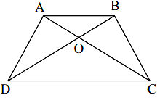23. ABCD is a trapezium in which AB || DC and its diagonals intersect each other at the point O. Show that = .

24. Determine if the points (1, 5), (2, 3) and (– 2, – 11) are collinear.

25. If m times the mth term of an A.P is equal to n times its nth term, show that the (m+n)th term of the A.P. is zero.

(or)

If Sn , the sum of first n terms of an AP is given by Sn = 3n2 – 4n , find the nth term and common difference.

**Section-C**

**III. Section C has 6 questions carrying 03 marks each.**

26. The HCF of 65 and 117 is expressible in the form of 65m-117. Find the value of m. Also, find the LCM of 65 and 117.

(or)

A fruit vendor has 990 apples and 945 oranges. He packs them into baskets. Each basket contains only one of the two fruits but in equal number. Find the number of fruits to be put in each basket in order to have minimum number of baskets.

27. If 𝛼, β are zeroes of quadratic polynomial f(x) = kx2 +4x + 4 such that 𝛼2 + β2 =24, find the values of k.

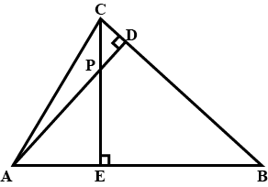28.In the given figure, altitudes AD and CE of Δ ABC

intersect each other at the point P. Show that:

(i) Δ AEP ~Δ CDP (ii) Δ ABD ~Δ CBE

29. If Q(0, 1) is equidistant from P(5, –3) and R(x, 6), find the values of x.

Also find the distances QR.

(or)

If A and B are (– 2, – 2) and (2, – 4), respectively, find the coordinates of P such that 7 AP = 3 AB and P lies on the line segment AB.

30. Draw the graphs of the equations 2x + y = 6 and 2x - y + 2 = 0. Shade the region bounded by these lines and x-axis. Find the area of the triangle formed.

31. If the roots of the equation (b-c) x2 + (c-a) x +(a-b) =0 are equal , then prove that 2b=a+c.

**Section-D**

**IV. Section D has 4 questions carrying 05 marks each.**

32. State and prove Basic Proportionality theorem. prove that a line drawn through the mid-point of one side of a triangle parallel to another side bisects the third side.

(or)

Sides AB and AC and median AD of a triangle ABC are respectively proportional to sides PQ and PR and median PM of another triangle PQR. Show that Δ ABC ~ Δ PQR.

33. (i)Prove that $6+\sqrt{7}$ is an irrational number.

(ii)Prove that 6n can never end with digit 0,where n is natural number.

34. A train travels a distance of 360 km at a uniform speed. If the speed had been 5 km/h more, then it would have taken 1 hour less for the same journey. Find the speed of the train.

(or)

A plane left 30 minutes later than the schedule time and in order to reach its destination 1500 km away in time it has to increase its speed by 250 km/hr from its usual speed. Find its usual speed.

35.(i)The taxi charges in a city consist of a fixed charge together with the charge for the distance covered. For a distance of 10 km, the charge paid is Rs 75 and for a journey of 15 km, the charge paid is Rs 110. What are the fixed charges and the charge per km? How much does a person have to pay for travelling a distance of 38 km?

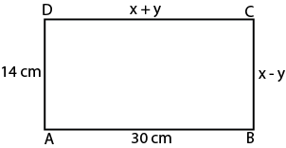

(ii) In a figure , ABCD is a rectangle .Find the values of

x and y.

**Section-E**

**V.CASE BASED QUESTION.**

36. Your younger sister wants to buy an electric car and plans to take loan from a bank for electric car. She repays her total of Rs 3,21,600 by paying every month starting with the first instalment of Rs 2000 and it increases the instalment by Rs 200 every month.



Based on the above information, answer the following questions.

(i) The amount paid by her in 25th instalment?

(ii) Find the difference of the amount in 4th and 6th instalment paid by younger sister?

(iii) In how many instalment, she clears her total bank loan?

OR

Find the sum of the first seven instalments.

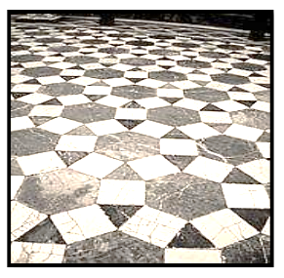37. A tiling or tessellation of a flat surface is the covering of a plane using one or more geometric shapes, called tiles, with no overlaps and no gaps. Historically, tessellations were used in ancient Rome and in Islamic art. You may find tessellation patterns on floors, walls, paintings etc. Shown below is a tiled floor in the archaeological Museum of Seville, made using squares, triangles and hexagons.

A craftsman thought of making a floor pattern after being inspired by the above design. To ensure accuracy in his work, he made the pattern on the Cartesian plane. He used regular octagons, squares and triangles for his floor tessellation pattern.

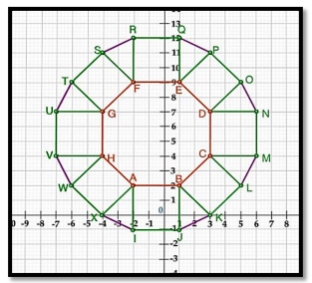

Use the above figure to answer the questions that follow:

(i) What is the length of the line segment joining points B and F?

(ii) The centre ‘Z’of the figure will be the point of intersection of the diagonals of quadrilateral WXOP. Then what are the coordinates of Z?

(iii) What are the coordinates of the point on y axis equidistant from A and G?

(OR)

What is the area of Trapezium AFGH?

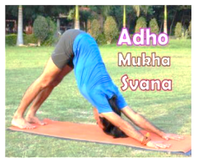38.An asana is a body posture, originally and still a general term for a sitting meditation pose, and later extended in hatha yoga and modern yoga as exercise, to any type of pose or position, adding reclining, standing, inverted, twisting, and balancing poses. In the figure, one can observe that poses can be related to representation of quadratic polynomial.

(i)What is the shape of the pose shown in above picture.

(ii) In the graph, how many zeroes are there for the polynomial and what are the zeroes.

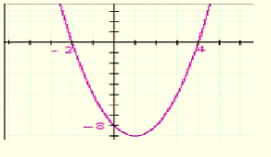

(iii) Find the zeroes of the quadratic polynomial $4\sqrt{3 }x^{2}+5x-2\sqrt{3}.$

(or)

Find the zeroes of the quadratic polynomial 3x2 -2 x +2 .